Address Book Guide

I’ve done the project with asp.net core 5

Prerequisites for the project

* .NET 5 SDK (<https://dotnet.microsoft.com/download/visual-studio-sdks>)
* pgAdmin 4(I used postgres)
* If you wish to choose other than postgres, you can change the connection string in appsettings.json:
* 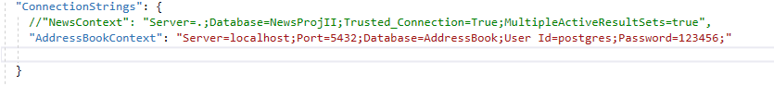

Note: I used code first approach, so after setting the connection string you open the package console and write **Update-Database. Then** you can run the project and Thank you 😊